Area of the Curriculum – Physical – Moving and Handling
Early Learning Goal: (expected to achieve by end of Reception)
Children show good control and co-ordination in large and small movements. They move confidently in a range of ways, safely negotiating space. They handle equipment and tools effectively, including pencils for writing.
Gross Motor –
Suggested activities
- Throwing and catching a ball – hand-eye coordination
- Target practice – throwing a ball into a bucket
- Football – control over the ball when kicking
- Tennis – hitting the ball with a bat
- Climbing, and Balancing - logs, climbing frames
- Hopping and skipping
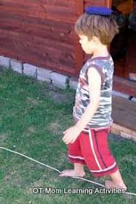

Fine Motor
Suggested activities
Pencil control- write using the tripod grip
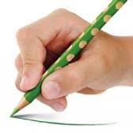
Please can your child use a writing pencil not a biro
Please practise forming the letters correctly (1 letter a day)
(theschoolrun.com/video-correct-letter-formation for adults to see how to form letters)
Suggestions to strengthen muscles to improve pencil control
- Pom poms and tweezers
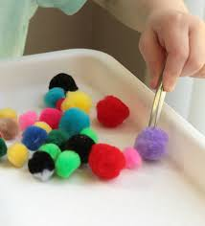

- Pegs
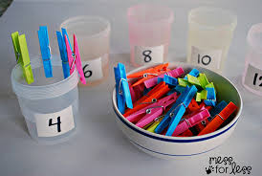

- Threading pasta
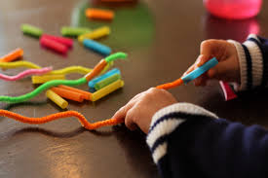
- Patterns with gems/counters
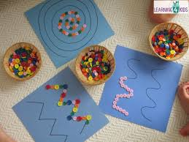
- Cutting using scissors
- Playdough – see recipe

Area of the Curriculum – Physical – Health and Self-Care
Early Learning Goal: (expected to achieve by end of Reception)
Children know the importance for good health of physical exercise, and a healthy diet, and talk about ways to keep healthy and safe. They manage their own basic hygiene and personal needs successfully, including dressing and going to the toilet independently
Suggested activities
- Dressing and undressing by themselves
- Keeping healthy
- Eating a variety of fruit and vegetables – making a fruit salad, smoothies or fruit/veg kebabs etc

-Daily exercise – dancing to favourite songs, jog round the garden, 10 star jumps, 10 jumps, 10 touch your toes etc
5 Minute Move Kids Workout -The Body Coach Joe Wicks on Youtube
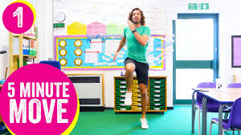
Cosmic Kids -Yoga, mindfulness and relaxation for kids. Interactive adventures which build strength, balance and confidence
https://www.youtube.com/user/CosmicKidsYoga

-Sleeping from NHS website
4 years night-time: 11 hours 30 minutes

5 years night-time: 11 hours
Books to read: many titles are available on YouTube




